|  |  |  |  |  |  |  |
| --- | --- | --- | --- | --- | --- | --- |
| **Exp. No** | **Conducted on** | **Submitted On** | **Date of Late Submission**  **(if Any)** | **Max Marks Allotted** | **Marks Obtained** | **Faculty Signature** |
| 1 |  |  |  | 10 |  |  |
| **Exp Title** | Exp No 8: Set Operation and Views | | | | | |

**Aim :- To study the implementation of Set Operators and Views.**

**Syntax (for all DDL Commands)**

# SQL Set Operation

The SQL Set operation is used to combine the two or more SQL SELECT statements.

## Types of Set Operation

1. Union
2. UnionAll
3. Intersect
4. Minus

**Queries (for all DDL Commands)**

SELECT column_name FROM table1

UNION

SELECT column_name FROM table2;

SELECT column_name FROM table1

UNION ALL

SELECT column_name FROM table2;

SELECT column_name FROM table1

INTERSECT

SELECT column_name FROM table2;

SELECT column_name FROM table1

MINUS

SELECT column_name FROM table2;

**Code:-**

create table First(id varchar(5), name varchar(10));

create table Second(id varchar(5), name varchar(10));

insert into First values('E1', 'Abhi');

insert into First values('E2', 'Adam');

insert into Second values('E2', 'Adam');

insert into Second values('E3', 'Chester');

SELECT * FROM First

UNION

SELECT * FROM Second;

SELECT * FROM First

UNION ALL

SELECT * FROM Second;

SELECT * FROM First

INTERSECT

SELECT * FROM Second;

SELECT * FROM First

MINUS

SELECT * FROM Second;

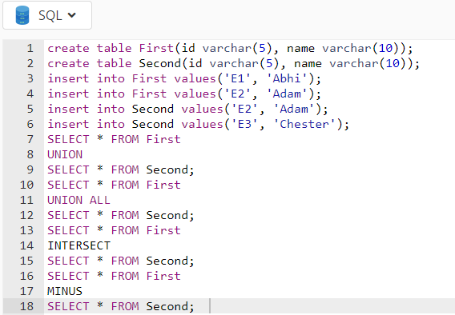

**Result:-**

E1|Abhi

E2|Adam Union

E3|Chester

E1|Abhi

E2|Adam Union All

E2|Adam

E3|Chester

E2|Adam Intersect

E1|Abhi Union

